Department of Technical Education
BET’s
MOTICHAND LENGADE BHARATESH POLYTECHNIC, BELAGAVI

FINAL REPORT

Capstone project Title: USB SECURITY KEY

Group Members:
- Manoj Kumar Patil
- Vishal Kadalagi
- Vinayak Kamkar

Chapter1:
  - Introduction
USB memory sticks can be found almost everywhere. Today, they can be seen as the replacement for floppy-disks, ZIP- drives and all that kind of media. A USB device is indeed a useful, economical way to transfer data. In fact, according to Gartner IT research and advisory company, there were roughly 222 million USB devices shipped in 2009. However, a recent study shows that though USB devices are a convenient means of transferring information, they can also serve as channels to transmit potential threats.

Sunnyvale (California, US) based security firm, Narus Inc. recently listed the 10 "cyber threat trends" for 2011 and beyond, claiming that as attacks through USB becomes inexpensive and data is circulated through them at various public and private locations, the probability of computer Trojans and other malicious software is increasing.

According to Panda’s report, 25% of worm based malware spreads through the USB drives. Even more, most of viruses are designed to spread via USB drives. Security Company confirms that cybercriminals are very persistent and put a lot of efforts to make user’s life impossible.

25% of latest created malware are configured to enter the system through portable storage devices, usually USB drives. Luis Corrons, the technical director of PandaLabs, the research arm of Panda Security comments: „Much of the malware in circulation has been designed to distribute through these devices. Not only does it copy itself to these gadgets, but it also runs automatically when a USB device is connected to a computer, infecting the system practically transparently to the user.

  - Scope of the Capstone Project:
The project aims to design and develop a USB Security Key that can be used to provide secure authentication and encryption of data. The device will be compatible with major operating systems such as Windows, Mac OS, and Linux. The USB Security Key will be designed to be user-friendly and provide a high level of security.

❖ Authentication
The project can focus on developing a USB Security Key that provides strong authentication mechanisms, such as biometric authentication or multi-factor authentication. The key should be designed to ensure that only authorized users can access protected resources.

❖ Encryption

The project can also focus on developing a USB Security Key that provides strong encryption mechanisms, ensuring that data stored on the device or transmitted over the network is secure and cannot be accessed by unauthorized users.

❖ User Experience
The project can focus on designing a USB Security Key that is user-friendly and easy to use, ensuring that users can quickly and easily authenticate themselves and access protected resources.

❖ Tamper-Proofing
The USB Security Key should be designed with tamper-
proofing mechanisms, making it difficult for attackers to modify
or manipulate the device to gain unauthorized access.

Chapter 2:
2.1 Capstone Project Planning

➢ Work Breakdown Structure (WBS)

Project Initiation
• Define project scope and objectives
• Develop project plan

Requirements Gathering
• Define security requirements
• Define hardware and software requirements
• Define user requirements

Design and Development
• Design security key hardware
• Develop firmware for the security key
• Develop software for managing the security key
•
Testing and Quality Assurance
• Conduct unit testing
• Conduct integration testing
• Conduct system testing
• Conduct user acceptance testing

Deployment
• Develop deployment plan
• Install security key hardware and software
• Conduct training for end-users

Maintenance and Support
• Provide ongoing maintenance and support
• Provide technical support to end-users
• Manage updates and upgrades to the security key

➢ TIMELINE Development:
- Planning Phase (27-Feb 2023 To 01 April 2023)
- Project plan:
  - Define project scope and objectives.
  - Identify project stakeholders and establish communication plan.
  - Develop a project schedule and budget.
  - Define project risks and develop a risk management plan.
- Feasibility study report:
  - Research existing USB security key technologies and standards.
  - Analyze technical and financial feasibility of the project.
  - Identify potential challenges and risks.

- Design Phase (03 April 2023 To 8 April 2023)
- Design specifications:
  - Identify hardware and software components required for the project.
  - Define the desired functionality and performance of the USB security key.
  - Establish design requirements and constraints.
- Detailed design plan:
  - Develop a detailed plan for assembling hardware components and integrating software.
  - Identify potential design challenges and risks

3.Development Phase (10 April 2023 To 15 April 2023)
- Prototype USB security key:
  - Assemble hardware components and integrate software.
  - Develop firmware and software to manage the security key.
  - Conduct functional and security testing.
- User interface:
  - Design a user-friendly interface for the USB security key.
  - Develop software for managing user settings and data.
  - Conduct usability testing.
- Test plan:
  - Develop a test plan to ensure the functionality and security of the USB security key.
  - Conduct testing and debugging.

- Implementation Phase (17 April 2023 To 29 April 2023)
- Final product:
  - Develop a final version of the USB security key.
  - Conduct final testing and debugging.
  - Obtain necessary certifications and approvals.
- User manual:
  - Develop a comprehensive user manual for the USB security key.
  - Include instructions for setup, data storage, and security management.
- Implementation plan:
  - Develop a plan for deploying the USB security key to end-users or within an organization.
  - Include training and support requirements.

- Evaluation Phase (1 May 2023 To 6 May 2023)
- Evaluation report:
  - Evaluate the performance and security of the USB security key.
  - Identify any issues or areas for improvement.
  - Develop recommendations for future iterations or updates

➢ Cost Breakdown Strucrure

COST ANALYSIS

EFFORT = a(KLOC)^b

TIME = c(EFFORT)^d

For Organic Project a,b,c,d Values are as Follows:
a = 2.4
b = 1.05
c = 2.5
d = 0.38

Estimated Man Power Cost Per Month is RS 500

COST CALCULATION

EFFORT = 2.4(1.1)^1.05 = 2.65
TIME = 2.5(2.65)^0.38 = 3.6
COST = 500*3*3.6*2.65 = RS 14310

➢ Work Breakdown Structure (WBS)

Design and Development Costs

• Hardware Design and Development
• Firmware Design and Development
• Software Design and Development

Testing and Quality Assurance Costs

• Unit Testing
• Integration Testing
• System Testing
• User Acceptance Testing

Manufacturing and Production Costs

• Materials for Manufacturing
• Manufacturing Equipment and Tools

Deployment Costs

• Shipping and Handling
• Installation Services
• Training Services

Maintenance and Support Costs

• Technical Support
• Upgrade and Update Costs
• Warranty and Repair Costs

Overhead Costs
• Rent and Utilities
• Office Supplies
• Legal and Accounting Fees

➢ Capstone project Risk Assesment:

Physical Security
One risk to consider is the physical security of the USB key.If someone were to steal the key, they could potentially access sensitive information. To mitigate this risk, physical security measures such as locking cabinets or secure keychains could be implemented.
Malware
Another risk to consider is the potential for malware to be introduced through the USB key. Malware could potentially compromise the securityof the device or the network it is connected to. To mitigate this risk, anti-virus software and secure boot processes could be implemented.

Compatibility
A potential risk is compatibility issues with different operating systems, browsers, and applications. To mitigate this risk, the key should be tested with various devices, and compatibility issues should be resolved before deployment.

Human error
A risk to consider is the potential for human error, such as losing the key, forgetting the password, or accidentally giving the key to unauthorized persons. To mitigate this risk, user training and clear policies on key usage and storage could be established.

Hacking
A significant risk is the potential for the key to be hacked, compromising the security of the data it stores. To mitigate this risk, strong encryption algorithms and protocols could be used, and the key should be regularly updated with the latest security patches and software.

2.2 Requirements Specifications
➢Functional:
Introduction:
The USB Security Key Project aims to develop a secure and reliable USB-based authentication system for enhanced data protection. The system will utilize USB security keys as hardware tokens to provide strong user authentication and access control for various applications. This document outlines the functional requirements of the project.

User Management:
User Registration:
- The system should allow users to register their USB security keys.
- Users must provide unique identification information during registration.
- The registration process should securely link the USB security key with the user account.

User Authentication:
- The system should support authentication using USB security keys.
- Users must be able to authenticate themselves by inserting their registered USB security key into the computer's USB port.
- The system should validate the key and grant access upon successful authentication.

Key Management:
Key Generation:
- The system should generate unique cryptographic keys for each USB security key during the registration process.
- Keys should be securely stored on the USB security key and never exposed or transmitted.

Key Revocation:
- The system should provide a mechanism to revoke USB security keys in case of loss, theft, or compromise.
- Revoked keys should be added to a blacklist and denied access during authentication.

Access Control:
Application Integration:
- The system should provide an interface or API for application developers to integrate USB security key authentication into their software.
- Applications should be able to request and validate user authentication using the USB security key.

Authorization Levels:
- The system should support multiple authorization levels (e.g., admin, user) for different user roles.
- Each USB security key should be associated with an appropriate authorization level.

Access Policies:
- The system should allow administrators to define access policies for different resources or functionalities.
- Access policies should specify which authorization levels are required to access specific resources.

System Administration:
Key Administration:
- Administrators should have the ability to manage registered USB security keys.
- This includes adding, removing, and updating key information.

Audit Logs:
- The system should maintain detailed logs of key registrations, authentications, and key management activities.
- Audit logs should be tamper-proof and accessible to authorized administrators.

System Security:
Encryption:
- All communication between the USB security key and the system should be encrypted to prevent eavesdropping or data tampering.

Secure Storage:
- The system should securely store user information, cryptographic keys, and access policies to prevent unauthorized access.

Two-Factor Authentication:
- The system should support two-factor authentication by combining USB security key authentication with another authentication factor (e.g., password).

➢ Non Functional:
Security:
Cryptographic Strength:
- The USB security key system must utilize strong cryptographic algorithms and protocols to ensure the security of user data and authentication processes.
- The cryptographic algorithms employed should adhere to industry best practices and standards.

Physical Security:
- The USB security keys must be designed to resist physical tampering and unauthorized access.
- The keys should be constructed using robust materials to withstand wear and tear.

Protection Against Attacks:
- The system should have built-in protections against various attacks, including but not limited to brute-force attacks, replay attacks, and key extraction attacks.
- The system should monitor and detect suspicious activities and take appropriate action, such as blocking access attempts.

Data Privacy:
- The system must handle user data and sensitive information in compliance with relevant data protection and privacy regulations.
- User data stored on the USB security keys and within the system should be securely encrypted and protected from unauthorized access.

Usability:
User-Friendly Interface:
- The system should provide an intuitive and user-friendly interface for users to register, manage, and authenticate with their USB security keys.
- Clear instructions and feedback should be provided to guide users through the authentication process.

Compatibility:
- The USB security key system should be compatible with a wide range of operating systems, including Windows, macOS, and popular Linux distributions.
- The system should support standard USB interfaces and be compatible with USB 2.0 and USB 3.0 standards.

Performance:
Response Time:
- The system should provide fast response times during user authentication to ensure a smooth user experience.
- The authentication process should be completed within an acceptable timeframe to avoid unnecessary delays.

Scalability:
- The system should be able to handle a large number of registered USB security keys and concurrent authentication requests without significant degradation in performance.
- The architecture and infrastructure should be designed to scale horizontally or vertically as the user base grows.

Reliability:
Availability:
- The system should have a high availability rate, ensuring that users can access the system and authenticate with their USB security keys at any time.
- Redundancy and fault tolerance mechanisms should be implemented to minimize downtime.

Error Handling:
- The system should have robust error handling mechanisms to handle exceptional scenarios gracefully.
- Meaningful error messages should be provided to users in case of failures or errors during authentication or key management processes.

➢ User Input:
User Interface:

The system should have a user-friendly interface that guides users through the registration and authentication processes.
The interface should be intuitive and provide clear instructions for using the USB security key.

Compatibility:

The USB security key should work seamlessly with a wide range of devices, including desktop computers, laptops, and mobile devices.
The system should support multiple operating systems, such as Windows, macOS, Linux, Android, and iOS.

Key Backup and Recovery:

Users should have the option to create backups of their USB security keys in case of loss or damage.
The system should provide a secure mechanism for key recovery, allowing users to restore their keys using the backup.

Cross-Platform Synchronization:

If a user has multiple devices, the system should provide synchronization capabilities to ensure that the USB security key works across all devices without requiring re-registration.

Offline Authentication:

The system should support offline authentication, allowing users to authenticate with their USB security key even when there is no internet connectivity.

➢ Technical Constraints:
USB Standards:

The USB security key system must adhere to USB standards, such as USB 2.0 or USB 3.0, depending on the target devices and compatibility requirements.
The system should ensure compatibility with USB connectors and ports commonly found in computers and other devices.

Hardware Limitations:

The design and functionality of the USB security key may be constrained by the available hardware capabilities and form factor.
Constraints may include limitations on storage capacity, processing power, memory, and power consumption of the USB security key.

Operating System Support:

The system must consider the limitations and compatibility requirements of different operating systems, such as Windows, macOS, Linux, Android, and iOS.
Device drivers or software libraries may need to be developed to support the USB security key on various platforms.

Cryptographic Algorithms and Standards:

The selection of cryptographic algorithms and standards for the USB security key should align with industry best practices and compliance requirements.
The system should consider the computational limitations of the USB security key in performing cryptographic operations efficiently.

Firmware Updates:

The USB security key should have a mechanism for receiving and applying firmware updates.
Constraints may include limitations on the size of firmware updates and the update process itself, considering the resources available on the USB security key.

Key Storage and Memory:

The USB security key's storage capacity and memory constraints should be considered when storing cryptographic keys, user data, and system-related information.
The system should optimize the use of available storage and memory resources to accommodate key storage and efficient operations.

2.3 Design Specification:
➢ Choosen System Design:
Chosen System Design for USB Security Key Project:

Architecture:

The chosen system design for the USB Security Key Project will follow a client-server architecture.
The server component will handle user registration, authentication, key management, and access control.
The client component will include the USB security key and the necessary software or drivers installed on the user's devices.

Components:
a. USB Security Key:

The USB security key will be a hardware token that connects to the user's device through a USB port.
It will store cryptographic keys, perform secure authentication, and handle secure communication with the server component.

b. Server Component:

The server component will be responsible for user management, key generation and revocation, access control, and authentication processes.
It will include a backend server application and a database for storing user information, keys, access policies, and audit logs.
The server component will communicate with the client component during authentication and key management operations.

c. Client Component:

The client component will consist of software or drivers installed on the user's devices, enabling communication with the USB security key and interaction with the server component.
It will provide a user-friendly interface for registration, authentication, and key management processes.
The client component will securely communicate with the server component, exchanging data and authentication requests.

Communication and Protocols:

The USB security key and the client component will communicate using secure communication protocols, such as Transport Layer Security (TLS) or Secure Shell (SSH), to ensure confidentiality and integrity.
Communication between the client component and the server component will take place over encrypted channels, using HTTPS or other secure protocols.
The USB security key will employ secure communication protocols, such as HID or custom protocols, to exchange authentication data with the client component.

Cryptographic Algorithms:

The system will utilize industry-standard cryptographic algorithms and protocols for key generation, encryption, and authentication processes.
Strong and proven algorithms, such as RSA, ECC, AES, and HMAC, will be used to ensure the security and integrity of user data and authentication mechanisms.

Data Storage and Security:

User information, cryptographic keys, access policies, and audit logs will be securely stored in a database within the server component.
User data will be encrypted and protected using appropriate encryption algorithms and secure storage mechanisms.
The server component will implement robust security measures to prevent unauthorized access, such as access controls, firewalls, and intrusion detection systems.

➢ Discussion of Alternative designs:
Standalone Authentication Device:

In this alternative design, the USB security key functions as a standalone authentication device without relying on a client-server architecture.
The USB security key contains all the necessary components and software to perform user authentication and key management operations independently.
Users would register their USB security keys directly with the device and perform authentication solely through the USB key without requiring server interaction.
This design offers increased privacy and offline functionality, but may limit the ability to centrally manage access control and perform real-time user monitoring.

Cloud-Based Authentication:

In this alternative design, the USB security key is used in conjunction with a cloud-based authentication service.
The USB key communicates with the cloud-based service for user registration, authentication, and key management operations.
The cloud service securely stores user credentials and performs the necessary authentication processes, while the USB key serves as a secure token for user verification.
➢ Detailed description of Components/Subsystems:

USB Security Key:

The USB security key is a hardware component that connects to a device's USB port and serves as a cryptographic token for authentication and secure communication.
It contains a microcontroller or secure element that stores cryptographic keys, performs cryptographic operations, and handles secure communication with the client component.
The USB security key may include LED indicators or a small display to provide status information during the authentication process.
It interacts with the client component and the server component to facilitate user registration, authentication, and key management operations.

Client Component:

The client component consists of software or drivers installed on the user's devices, enabling communication with the USB security key and interaction with the server component.
It provides a user-friendly interface for users to register their USB security keys, perform authentication, and manage key-related operations.
The client component facilitates secure communication with the USB security key, exchanging authentication data and cryptographic operations.
It may include functionalities such as key backup and recovery, synchronization across devices, customization options, and integration with other authentication factors.

Server Component:

The server component is responsible for managing user accounts, authentication processes, key generation and revocation, access control, and auditing.
It consists of a backend server application and a database for storing user information, cryptographic keys, access policies, and audit logs.
The server component receives authentication requests from the client component, verifies the user's identity, and grants or denies access based on predefined access policies.
It securely communicates with the client component, exchanging authentication data, cryptographic keys, and other relevant information.
The server component may also include administrative interfaces for user management, key management, and monitoring user activities.

Cryptographic Subsystem:

The cryptographic subsystem encompasses the algorithms, protocols, and operations related to cryptographic functions performed by the USB security key and the server component.
It includes cryptographic algorithms for key generation, encryption, digital signatures, and secure communication.
The subsystem ensures the confidentiality, integrity, and authenticity of user data and

Database and Storage Subsystem:

The database and storage subsystem is responsible for securely storing and managing user information, cryptographic keys, access policies, and audit logs.
It ensures the integrity and confidentiality of stored data by employing encryption, access controls, and secure storage mechanisms.
The subsystem supports efficient retrieval and updating of user data and provides backup and recovery mechanisms to prevent data loss.
It may also integrate with authentication and authorization frameworks for seamless access control management.

Communication Subsystems:

The project may include multiple instances of communication subsystems.
These subsystems facilitate secure communication between each client component and its associated server component.

➢ Component 1 - n:
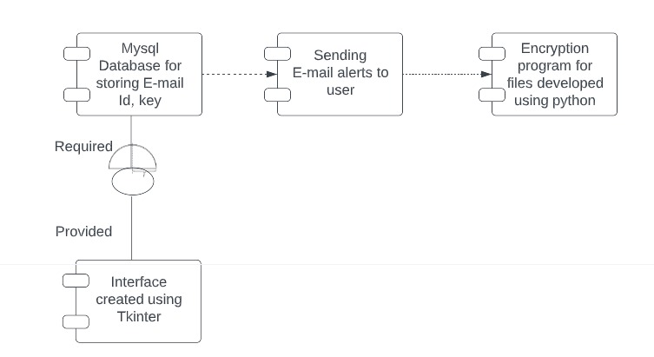

Chapter 3:

Approach and Methodology:

Waterfall Methodology

Waterfall methodology is a linear approach to project management. It involves defining all project requirements upfront and then executing the project in a sequential manner, with each phase of the project building on the previous one. Waterfall is well-suited for projects where requirements are well-defined upfront, and where there is a clear understanding of the project scope, timeline, and budget.

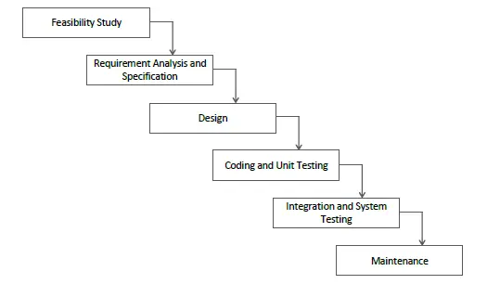

Description of Technology Used

- USB Connector: A USB connector is used to connect the USB Security Key to a computer or other device that provide authentication and cryptographic capabilities. These tokens store encryption keys, digital certificates, and user credentials in a secure, tamper-resistant environment. They enable strong authentication and help verify the identity of users before granting access to USB devices.
- Non-volatile memory: A USB Security Key typically contains non-volatile memory, such as EEPROM or flash memory, to store security keys and other authentication data.
- Cryptographic algorithms and protocols: Cryptographic algorithms and protocols are used to ensure the security and integrity of the authentication process. These may include algorithms such as RSA or AES, and protocols such as U2F or FIDO2.
- Encryption Algorithms: Encryption algorithms are fundamental to USB security systems. They are used to encrypt the data stored on USB devices, making it unreadable without the appropriate decryption key. Advanced encryption algorithms such as AES (Advanced Encryption Standard) are commonly employed to provide robust data protection.
- Access Control Mechanisms: Access control mechanisms are implemented to regulate and restrict access to USB devices. This can involve user authentication through passwords, PINs, biometric identification (fingerprint or facial recognition), or the use of cryptographic keys stored on USB tokens. Access control ensures that only authorized individuals can use or access the USB devices.

Project Process Design:

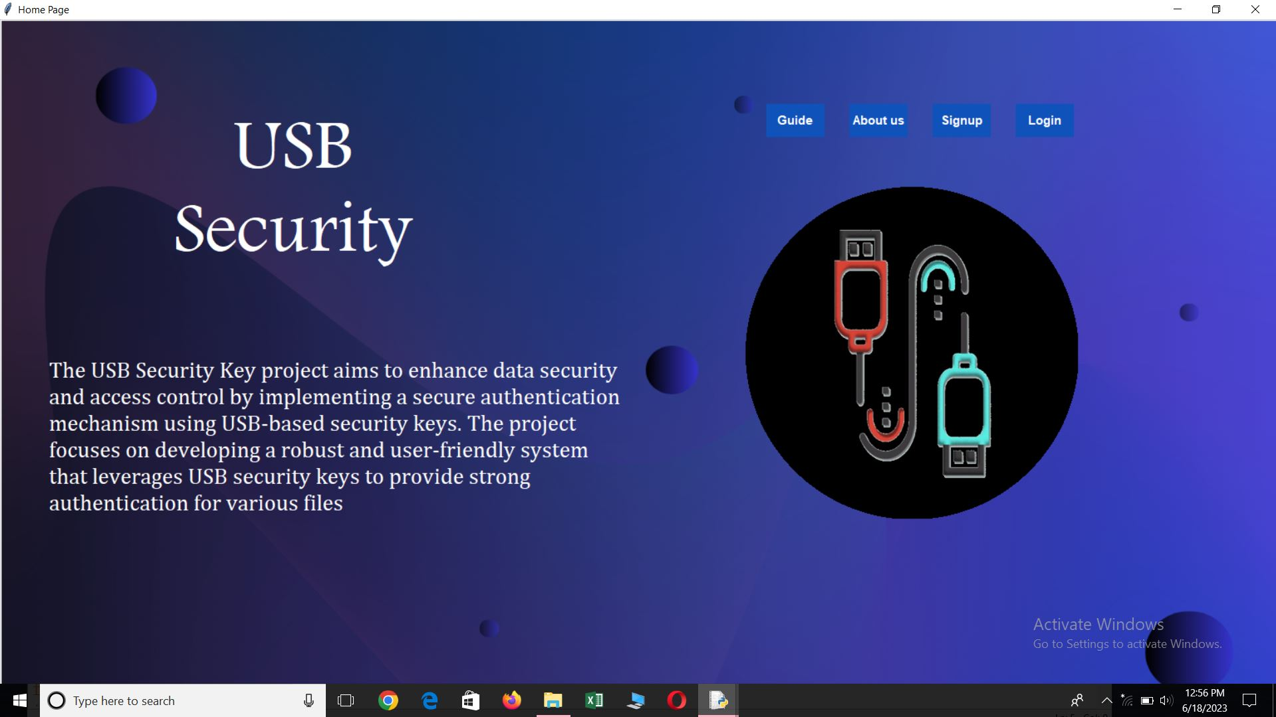
Home Screen Design:

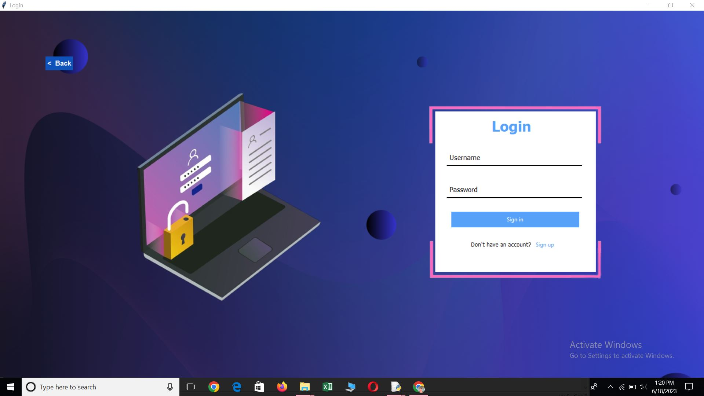
Login Screen Design:

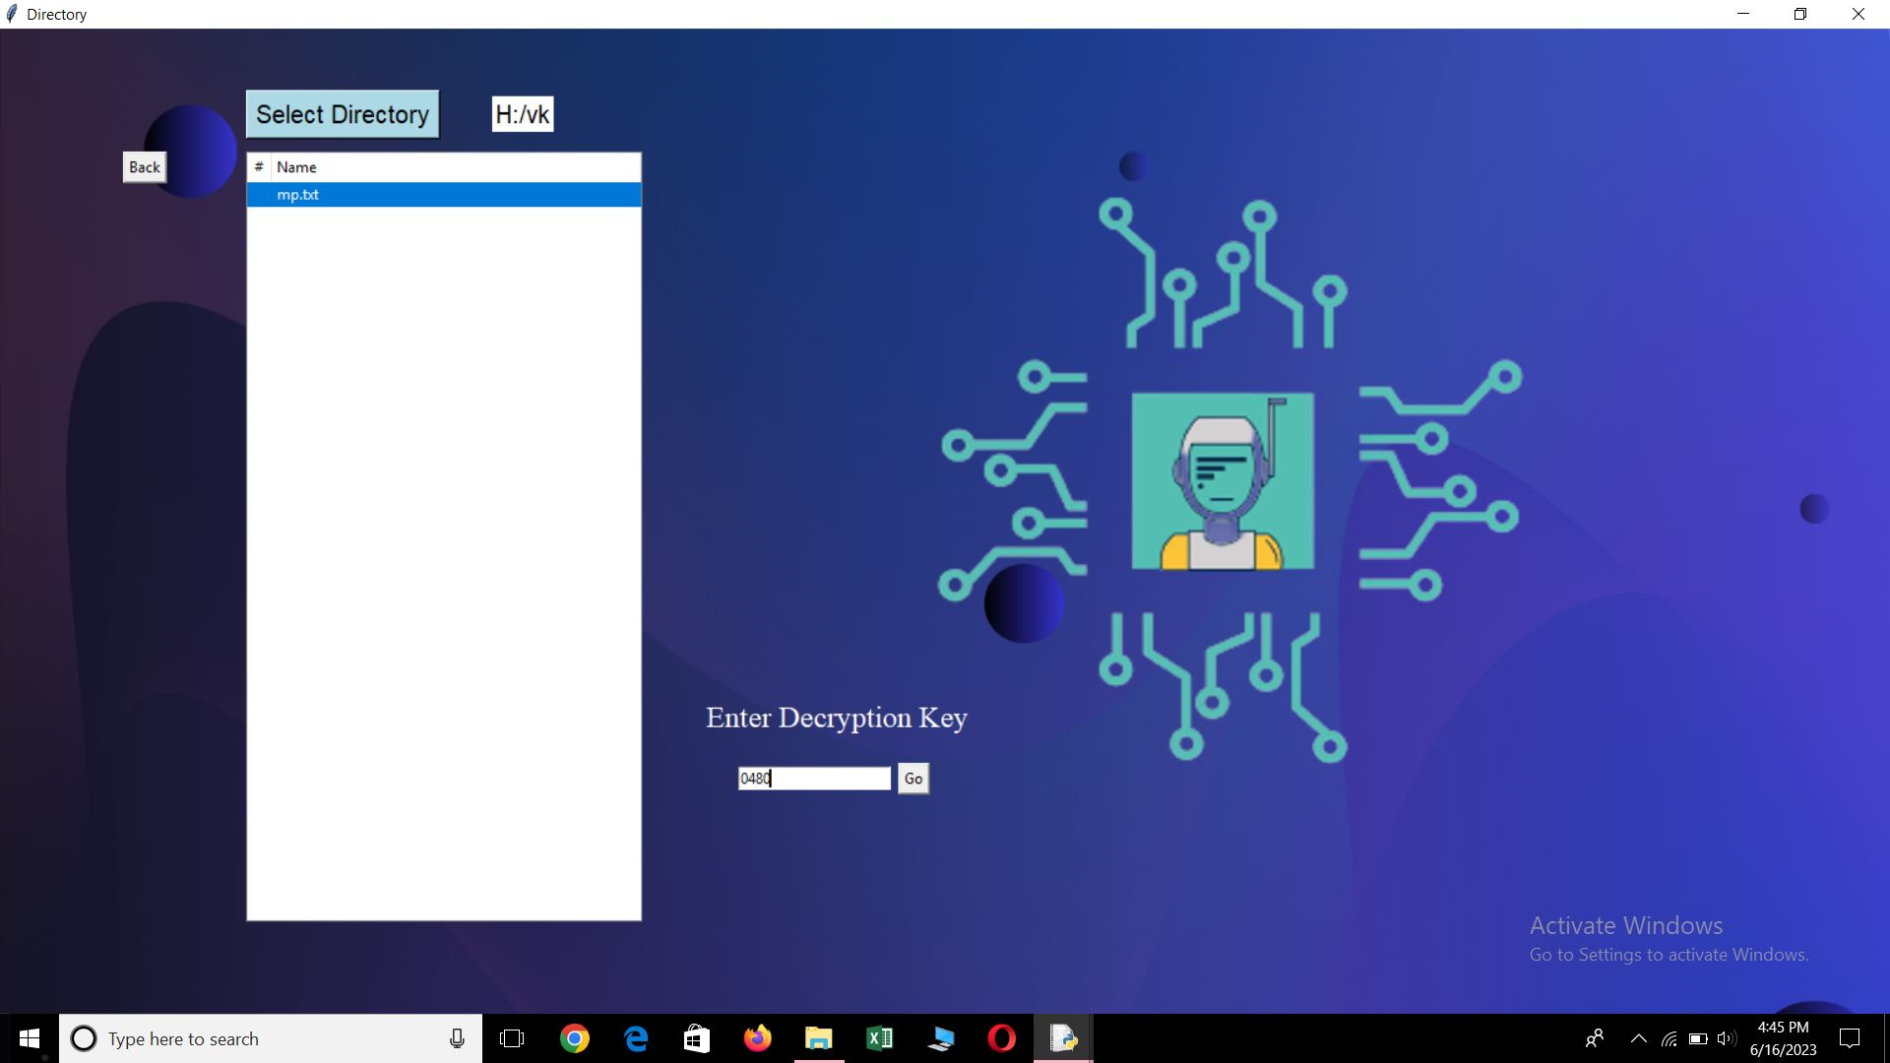
Product Design:

Chapter 4:

4.1 Test Plan:

Objective:
The objective of the test plan is to verify the functionality, security, and performance of the USB Security Key Project, ensuring that it meets the specified requirements and provides a reliable and secure authentication solution.

Test Scope:

Registration and Enrollment:

Test user registration process, including account creation, USB security key association, and user profile setup.

Authentication:
Test the USB security key authentication process, including successful and unsuccessful authentication attempts.
Verify the system's ability to detect and prevent unauthorized access.

Key Management:
Test key generation and revocation processes.
Verify that cryptographic keys are securely stored and managed.

Access Control:
Test access control mechanisms, including enforcing access policies and permissions based on user roles.

Secure Communication:
Test the secure communication between the USB security key, client component, and server component.
Verify that data transmitted between components is encrypted and protected from unauthorized access.

Performance:
Test the system's performance under expected user load and stress conditions.
Verify the response time, throughput, and scalability of the system.

4.2 Test Approach:

Test Planning:

Define the test objectives, scope, and priorities based on the project requirements and constraints.
Identify the key functionalities and critical components that need to be tested.
Determine the testing techniques, tools, and resources required.
Allocate appropriate time and resources for each testing phase.

Test Design:

Develop a comprehensive set of test cases covering both functional and non-functional requirements.
Create positive and negative test scenarios to ensure adequate coverage.
Define test data and test environment setup requirements.
Determine the appropriate test techniques, such as equivalence partitioning, boundary value analysis, and error guessing.
Test Execution:

Execute the test cases based on the defined test plan and test cases.
Perform unit tests, integration tests, system tests, and acceptance tests as applicable.
Record test results, including any issues or defects identified during testing.

Functional Testing:

Verify that the USB security key performs the intended functions accurately and efficiently.
Validate user registration, authentication, key management, and access control processes.
Test for proper handling of various inputs, error conditions, and boundary cases.
Conduct tests to ensure secure communication between components.

Security Testing:

Perform security testing to identify and mitigate potential vulnerabilities.
Test for common security risks, such as injection attacks, cross-site scripting (XSS), and authentication bypass.
Validate the confidentiality, integrity, and availability of sensitive user information and cryptographic keys.

Performance Testing:

Assess the performance of the USB Security Key system under different load conditions.
Conduct load testing to determine the system's scalability and response time.
Measure resource utilization, throughput, and latency to ensure optimal performance.

Compatibility Testing:

Test the compatibility of the USB security key and client components with various operating systems, devices, and browsers.
Validate that the system functions correctly across different platforms and configurations.

4.3 Features Tested:

- Home Page Window (1st Screen)

Sl No. | Test Case Description | Expected Result | Remarks
1. | Canvas dimensions | Verify that the canvas size is 2000x1000 pixels. | Yes
2. | Canvas background image | Ensure that the canvas displays the "purple.png"  Image. | Yes
3. | Label text placement and appearance | Check that the labels "USB" and "Security" are displayed correctly. | Yes
4. | Label text font and color | Ensure that the labels have the specified font and  Color. | Yes
5. | Label button functionalities (About us, Signup, Login) | Clicking on each label button should trigger the corresponding action/function. | Yes
6. | Label button appearance | Verify that the label buttons have the specified background color, text color, font, and size. | Yes
7. | Video frame display | Check that the video frames are displayed  correctly on the canvas. | Yes
8. | Video frame update | Verify that the video frames update at a  regular interval. | Yes
9. | Window title | Verify that the window title is set to "Home Page". | Yes

About Us Page Window (2nd Screen)
Sl No. | Test Case Description | Expected Result | Remarks
1. | Window title | Verify that the window title is set to "About us". | Yes
2. | Canvas dimensions | Ensure that the canvas size is 1600x1000 pixels. | Yes
3. | Canvas background image | Ensure that the canvas displays the "purple.png"  Image. | Yes
4. | Video playback | Verify that the video is played correctly on the window. | Yes
5. | Hyperlink functionality - Open link1 | Clicking on "@mr_manoj7022" should open the specified Instagram profile in a web browser. | Yes
6. | Hyperlink functionality - Open link2 | Clicking on "@itss_vin_17" should open the specified Instagram profile in a web browser. | Yes
7. | Hyperlink functionality - Open link3 | Clicking on "@vishal_k01" should open the specified Instagram profile in a web browser. | Yes
8. | Phone number functionality - Label4 | Clicking on the phone number "+91 7022820630" should perform the expected action. | No
9. | Phone number functionality - Label5 | Clicking on the phone number "+91 9380338484" should perform the expected action. | No
10. | Phone number functionality - Label6 | Clicking on the phone number "+91 6360430056" should perform the expected action. | No
11. | Button functionality - w1b1 (Back button) | Clicking on the "Back" button should close the current window. | Yes

Guide Page Window(3rd Screen)
Sl No. | Test Case Description | Expected Result | Remarks
1. | Window title | Verify that the window title is set to "Guide". | Yes
2. | Canvas dimensions | Ensure that the canvas size is 1600x1000 pixels. | Yes
3. | Canvas background image | Check that the canvas displays the "purple.png" image. | Yes
4. | Video playback | Verify that the video is played correctly on  the window. | Yes
5. | Button functionality - w8b8 (Back button) | Clicking on the "Back" button should close the current window. | Yes

Signup Page Window(4th Screen)

Sl No. | Test Case Description | Expected Result | Remarks
1. | Window title | Verify that the window title is set to "Signup". | Yes
2. | Database connection | Ensure that the connection to the MySQL database is successful. | Yes
3. | Insert values into the database | Verify that the values entered by the user are inserted into the database. | Yes
4. | Entry fields - Name, Last Name, Phone No, Email, Username | Check that the entry fields display the default text and accept user input. | Yes
5. | Entry fields validation | Verify that the entry fields are cleared when the user clicks on it. | Yes
6. | Sign up button | Verify that clicking on the "Sign up" button triggers the insertion of values into the database. | Yes
7. | Sign in button | Verify that clicking on the "Sign in" button navigates to the sign-in window. | Yes
8. | Button functionality - w2b2 (Back button) | Clicking on the "Back" button should close the current window. | Yes
9. | Canvas background image | Check that the canvas displays the "purple.png" image. | Yes
10. | Canvas image | Check that the canvas displays the  “insideimage-removebg-preview.png” image. | Yes
Login Page Window(5th Screen)

Sl No. | Test Case Description | Expected Result | Remarks
1. | Window title | Verify that the window title is set to "Login". | Yes
2. | Database connection | Ensure that the connection to the MySQL database is successful. | Yes
3. | Valid Login Credentials | The user should be logged in successfully, and the "generate_key()" function should be called. | Yes
4. | Invalid Login Credentials | An message box should be displayed, indicating  that the “Record does not exist”. | Yes
5. | Empty Username and Password | The input fields should display the default placeholder text ("Username" and "Password") without any error messages. | Yes
6. | Sign up button | Verify that clicking on the "Sign in" button navigates to the sign-up window. | Yes
7. | Button functionality – w3b3 (Back button) | Clicking on the "Back" button should close the current window. | Yes
8. | Canvas background image | Check that the canvas displays the "purple.png" image. | Yes
9. | Canvas image | Check that the canvas displays the  “login image.png” image. | Yes
10. | Sign in button | Verify that clicking on the "Sign up" button triggers the next window. | Yes

Detection of USB(6th Screen)

Sl No. | Test Case Description | Expected Result | Remarks
1. | Window title | Verify that the window title is set to "USB Detection". | Yes
2. | Check Button | Verify that clicking the "Check" button when a removable disk is detected or not detected plays the appropriate video and displays the correct message. | Yes
3. | Next Button | Verify that clicking the "Next" button after a removable disk is detected proceeds to the next window. | Yes
4. | Exit Button | Verify that clicking the "Exit" button when a removable disk is not detected closes the USB detection window. | Yes
5. | Back Button | Varify that clicking on “Back” Button returns to the previous window. | Yes
6. | Canvas background image | Check that the canvas displays the "purple.png" image. | Yes
7. | Canvas image | Check that the canvas displays the  “login image.png” image. | Yes
8. | Video playback | Verify that the specific video is played correctly on  the window when clicking on the check Button. | Yes

Key Generation(7th Screen)
Sl No. | Test Case Description | Expected Result | Remarks
1. | Window title | Verify that the window title is set to "Key Generation". | Yes
2. | Generate key button clicked | “Decryption Key has sent to Email id” message box displayed. | Yes
3. | Email successfully sent | Email with OTP is sent to the specified address. | Yes
4. | OTP inserted into the database | OTP is successfully inserted into the database. | Yes
5. | Video displayed on the  canvas | Video is displayed in the specified frame on  the canvas. | Yes
6. | Canvas background image | Check that the canvas displays the "blured 1.png" image. | Yes
7. | "< Back" label button clicked | Window is closed and returns to the previous window. | Yes
8. | Canvas Text | Check that canvas text dispayed on the window. | Yes

Disp – Select Directiory(8th Screen)
Sl No. | Test Case Description | Expected Result | Remarks
1. | Window title | Verify that the window title is set to "Directiory". | Yes
2. | SQL connection | Varify the Sql connection. | Yes
3. | Canvas text | Check that canvas text dispayed on the window. | Yes
4. | "Select Directory" button clicked | A directory selection dialog should open, allowing the user to choose a directory. | Yes
5. | Double-click on a file in the treeview | If the decryption key is correct, the selected file should open. | Yes
6. | Canvas background image | Check that the canvas displays the "purple.png" image. | Yes
7. | "< Back" label button clicked | Window is closed and returns to the previous window. | Yes
8. | Canvas image | Check that the canvas displays the " disp ima.png " image. | Yes
9. | Enter an incorrect  decryption key and  click the "Go" button. | A warning message should be displayed, indicating that the decryption key is incorrect. | Yes
10. | Enter a correct  decryption key and  click the "Go" button. | If the key is correct, the selected file  should open. | Yes

Chapter 5:

5.1 Buisness Aspects:

- Market and economical outlook:

Growing Demand for Secure Authentication:
With the rise in cyber threats and data breaches, organizations across industries are prioritizing robust authentication mechanisms. USB security keys offer enhanced security compared to traditional passwords, making them an attractive solution for protecting sensitive data and systems.

Growing Remote Workforce:
The shift towards remote work and cloud-based systems has created a need for secure remote access solutions. USB security keys provide a portable and secure authentication method for remote employees, ensuring that only authorized individuals can access critical systems and data.

Technological Advancements:
USB security key technology continues to evolve, with advancements in hardware, firmware, and encryption algorithms. These advancements enhance the security, performance, and usability of USB security keys, making them more appealing to organizations.

- Novel Features of the Product:

Advanced Cryptographic Algorithms: The USB security key could utilize advanced cryptographic algorithms, such as Elliptic Curve Cryptography (ECC) or post-quantum cryptography, to provide strong encryption and key management capabilities. This ensures that user data and communications are secure against emerging threats.

- Product Fit into the Competitive landscape:

Enhanced Security:

Emphasize the strong security measures offered by the USB security key project. Highlight features like tamper-resistant hardware, advanced cryptographic algorithms, and multi-factor authentication, which provide a higher level of security compared to traditional password-based authentication methods.

Ease of Use:

Focus on providing a user-friendly experience. Ensure that the USB security key is easy to set up, intuitive to use, and seamlessly integrates with popular platforms and applications. Simplifying the authentication process and minimizing user friction can be a significant differentiator in the market.

Cost-Effectiveness:

Offer a cost-effective solution compared to other authentication methods. Position the USB security key project as a cost-efficient alternative to smart cards, biometric systems, or proprietary hardware tokens. Highlight the long-term cost savings, such as reduced password-related support costs and enhanced security against potential breaches.

- Projected Clients:

- Manoj kumar Patil
- Vishal Kadalagi
- Vinayak Kamkar

5.2 Financial Considerations:

Project Overall Budget:

COST ANALYSIS:
EFFORT = a(KLOC)^b

TIME = c(EFFORT)^d

For Organic Project a,b,c,d Values are as Follows:
a = 2.4
b = 1.05
c = 2.5
d = 0.38
Estimated Man Power Cost Per Month is RS 500

COST CALCULATION:

EFFORT = 2.4(1.1)^1.05 = 2.65
TIME = 2.5(2.65)^0.38 = 3.6
COST = 500*3*3.6*2.65 = RS 14310/-

- Cost projection needed for Profit Options:

For-Profit Option:

Development Costs: This includes expenses related to software development, hardware design, firmware development, and integration. The costs may involve hiring developers, engineers, and designers or outsourcing development work to a third-party provider.

Hardware Components: The cost of procuring USB security key hardware components, including secure microcontrollers, memory chips, connectors, and casings.
Testing and Quality Assurance: Allocating a budget for testing activities, including functional testing, security testing, performance testing, and compatibility testing across different platforms and devices

For our USB Security Key Project Cost is about 14310rs .We recommend Profit option itself because our project is well executable and easy to use because of this reason we for profit option nor for Non Profit option.

5.3 Conclusions And Recommendations:

- State of Completion Of Our Project:

Planning and Design: The project is in the initial stages, where the concept and requirements for the USB security key are defined. The team is conducting market research, identifying the target audience, and outlining the key features and specifications of the product.

Development: The project has progressed to the development phase, where the hardware, firmware, and software components of the USB security key are being designed and implemented. The development team is working on integrating security features, authentication protocols, and compatibility with different platforms and systems.

Prototype: A functional prototype of the USB security key has been created. The prototype may undergo testing and iterations to ensure it meets the desired functionality, security standards, and user experience expectations. Feedback from testing helps refine the design and identify any necessary improvements.

Manufacturing: The project has reached the manufacturing stage, where the USB security keys are being produced on a larger scale. The production process includes sourcing components, assembly, quality control, and packaging.
Testing and Quality Assurance: The manufactured USB security keys undergo rigorous testing and quality assurance procedures. This includes functional testing, security testing, compatibility testing, and performance testing to ensure the keys meet the required standards and specifications.

Deployment and Distribution: The USB security keys are ready for deployment and distribution. They are packaged and prepared for shipment to customers, whether they are individual users or organizations. Distribution channels and logistics are established to deliver the product to the intended market.

- Future Work

The future work of a USB security key project involves ongoing improvements and advancements to enhance its features, security, and usability. The future work areas aim to continually enhance the USB security key project, keeping it relevant, secure, and user-friendly in the face of evolving security challenges and user requirements.

Outline how the usb security key project may extended

New Features and Authentication Methods:

Integrate additional authentication methods such as voice recognition, iris scanning, or gesture recognition for enhanced security and user convenience.
Explore biometric-based authentication using built-in sensors on the USB security key, allowing users to authenticate with their unique biometric data.
Implement context-aware authentication, where the key adapts its authentication requirements based on factors such as location, time, or user behavior.

Cloud-Based Management and Remote Control:

Develop a cloud-based management platform that allows users to remotely manage their USB security keys, including key provisioning, revocation, and firmware updates.
Enable remote control and tracking features to allow users to locate, lock, or wipe their USB security keys in case of loss or theft.

Expanded Platform Compatibility:

Extend platform compatibility to include emerging operating systems, mobile devices, and IoT devices, ensuring the USB security key can be used across a wide range of platforms and ecosystems.
Integrate with popular cloud services, identity providers, and single sign-on solutions, allowing users to seamlessly authenticate and access their accounts and applications.

